Bluetrace: A Local Web Workflow for Satellite Oil Slick Screening and Probable Vessel Source Association: Design, Baseline Evaluation and Validation Plan
Ashwinsha P  Department of Computer Science and Engineering  Vellore Institute of Technology  Vellore, Tamil Nadu, India | Sanjay Ramaswamy S  Department of Computer Science and Engineering  Vellore Institute of Technology  Vellore, Tamil Nadu, India | Rakesh N  Department of Computer Science and Engineering  Vellore Institute of Technology  Vellore, Tamil Nadu, India

Abstract—Satellite radar images can show dark slicks on the sea surface, but a slick drifts away from where it was released, so a vessel that happens to be close at the time of observation is not necessarily the source. This paper describes Bluetrace, a local web application that puts image screening, back-tracked source estimation and vessel track evidence into one workflow that an analyst can inspect. A random forest classifies every pixel of a 200 × 150 SAR tile using twelve hand-crafted features. It was trained on the public Garcia-INPE Oil Spill Segmentation Dataset (173 image–mask pairs from 24 source images), with the split made by source image, and it was tested on 22 held-out tiles (660,000 pixels). On this test set it reached a slick IoU of 53.26%, a precision of 56.59% and a recall of 90.07%, compared with 6.64%, 6.64% and 99.65% for a dark-percentile baseline. Region centroids are moved back along an analyst-entered drift (current plus windage times wind) for nine ages. AIS tracks are interpolated only inside observed intervals and are ranked with a score made of 0.70 spatial, 0.20 temporal and 0.10 completeness terms. Investigations are saved in SQLite and exported as JSON and GeoJSON, and 23 automated tests passed. The vessel stage was run only on a fictional demonstration, so no real source vessel has been validated, and the score is a ranking aid and not a probability of responsibility.
Index Terms—oil spill detection, synthetic aperture radar, AIS, drift back-tracking, random forest, web application, reproducibility.
I. INTRODUCTION
Synthetic aperture radar (SAR) can see the sea surface day and night and through cloud. A film of oil damps the small waves that scatter radar energy back to the satellite, so a slick usually appears as a dark patch [1], [2]. The same darkening is also caused by low-wind areas, biogenic films and other look-alikes [3]. A dark region in an image is therefore only a candidate slick and not proof of oil.
A second problem comes after detection. Oil moves with the surface current and, to a smaller degree, with the wind, so by the time a satellite passes over, the release may have happened hours earlier and some kilometres away. Automatic identification system (AIS) messages give vessel positions [4], but the vessel that is nearest to a slick at observation time is not necessarily the vessel that released it. Treating proximity as origin would turn a coincidence into an accusation.
Most published work looks at one part of this chain: detection and classification of dark spots, drift modelling, or ship detection with AIS. The parts are rarely put in front of an analyst together with their assumptions visible. Here we ask whether a small local web application can hold the whole chain, from image to ranked vessel evidence, and still keep every assumption in view. We think a useful tool must meet three requirements: (1) it should show the input image, the predicted mask and an overlay so that screening can be checked by eye; (2) it should expose every number behind an association, namely drift, age, uncertainty radius and time alignment, and never extrapolate a vessel track silently; and (3) it should save, reopen and export each investigation in standard formats so that a result can be reproduced and challenged. The contribution is a reproducible investigation workflow with visible evidence, and not a claim of a new detection algorithm.
II. RELATED WORK AND LITERATURE SURVEY
Work on satellite oil spill monitoring can be grouped into three lines: classical dark-spot detection and classification, deep semantic segmentation, and drift modelling with vessel data.
A. SAR Slick Detection and Classification
Operational pipelines usually find dark formations, compute shape, contrast and context features for each one, and then classify them [5], [6]. Statistical classifiers [5], neural networks [7] and decision tree forests for feature selection [8] have all been used, and Kubat et al. [9] studied learning when slick examples are rare. Polarimetric features were examined by Skrunes et al. [10], and general reviews are given in [1], [2], [11]. Fiscella et al. [12] showed marine SAR detection of slicks, and Alpers et al. [3] describe the challenges and pitfalls caused by look-alikes. The common message is that a dark region needs further evidence before it is called oil.
B. Deep Learning and Lightweight Baselines
Fully convolutional networks [13] and U-Net [14] made dense pixel prediction standard in image analysis, and Krestenitis et al. [15] applied deep networks to Sentinel-1 oil spill images. Reviews of deep learning in remote sensing are given by Zhu et al. [16]. Such models need large labelled sets and often a GPU. The public set used here has only 173 image–mask pairs, so we use a small random forest [17] from scikit-learn [18] as a transparent baseline and compare it with a simple dark-percentile rule. We do not claim that it is state of the art.
C. Drift Modelling and Vessel Association
Wind-induced drift of floating objects is often treated as the water current plus a fraction of the wind, and the leeway method [19] and search-and-rescue models [20] build on this idea. Trajectory frameworks such as OpenDrift [21], oil weathering models such as ADIOS [22] and reviews [23] cover much richer physics, and trajectory modelling was applied to the Deepwater Horizon spill [24]. These systems need gridded forcing data and expert set-up. On the vessel side, Pelich et al. [25] used AIS to evaluate SAR ship detectors, and Kroodsma et al. [26] used AIS to map fishing activity. We did not find a small local tool that links a detected slick, a simple back-tracked source area and AIS evidence while exposing every assumption. Table I lists the main earlier mechanisms and the question each one leaves for this work.
TABLE I
PRIOR MECHANISMS AND THE QUESTIONS THEY LEAVE OPEN
Source | Existing method | Question for this work
[1], [5], [6] | Dark-spot detection, feature extraction, classification | Can a simple learned screener beat a dark threshold on held-out scenes?
[13]–[15] | Deep semantic segmentation | Can a light model run interactively on a CPU?
[19], [21], [22] | Leeway and trajectory models | Can transport assumptions be typed in and shown plainly?
[4], [25], [26] | AIS tracks and SAR–AIS comparison | Can AIS be aligned in time without extrapolation?

III. BASELINE REVIEW AND LIMITS OF PROXIMITY
The simplest approach has two steps. First, threshold the darkest pixels of the image. Second, name the vessel that is nearest to the dark region at observation time. This has three weaknesses. A dark-percentile rule flags dark but harmless sea as readily as oil, and because slick pixels are only 1.10% of the test pixels (Section IX), the implemented dark-percentile comparator reaches a precision of only 6.64%. Proximity at observation time ignores both drift and slick age, so a vessel that is close now may have arrived after the release, and the true source may already be far away. Finally, raw AIS reports are sparse and uneven, and drawing a straight line across a long gap or an impossible speed jump invents a position that was never reported. Table II compares this baseline with Bluetrace. The proximity rule was not implemented as a competitor; it is described only to show the gap the workflow tries to close, whereas the dark-percentile comparator was implemented and tested.
TABLE II
PROXIMITY BASELINE AND BLUETRACE
Aspect | Proximity baseline | Bluetrace
Detection | Dark-percentile threshold | Random forest, 12 features, validation-chosen threshold
Origin | Vessel position at observation time | Back-tracked source circles for nine ages
AIS handling | Latest reported position | Per-MMSI sorting, de-duplication, guarded interpolation
Output | One vessel name | Ranked candidates with score terms shown
Uncertainty | None | Analyst-defined radius that grows with age
Persistence | None | SQLite snapshot with JSON and GeoJSON export

IV. HYPOTHESIS AND RESEARCH QUESTIONS
Our hypothesis is that a local web workflow that joins a pixel classifier validated on held-out source images with explicit back-tracking and guarded AIS interpolation can give analysts inspectable and reproducible association evidence, without presenting a ranking as proof of responsibility. The study is built around four research questions.
RQ1 (Screening accuracy): Does a twelve-feature random forest give a higher slick IoU than a dark-percentile baseline on tiles from source images that were never used in training?
RQ2 (Association transparency): Can back-tracked source circles and guarded AIS interpolation produce ranked candidates whose inputs and score terms are all visible and exportable?
RQ3 (Workflow integrity): Can the analyse, save, reopen, export and delete lifecycle, input validation and failure clean-up be checked by automated tests?
RQ4 (Resource budget): Can training and per-tile inference run on one CPU in seconds and milliseconds, respectively, without a GPU?
V. SYSTEM ARCHITECTURE AND WEB INTERFACE
Fig. 1 shows the implemented components. The browser sends JSON with fetch. The backend validates the inputs, runs the analysis, writes an incident snapshot and stores three PNG assets, and the browser then uses the returned result to update cards, images, source contours and vessel evidence without reloading the page. The server uses the Python standard-library HTTP server with NumPy [27], SciPy [28], Pillow, scikit-learn [18] and joblib, and it binds to the local computer only. The front end is HTML5, CSS3, vanilla JavaScript and SVG, so no external map service or build system is needed.
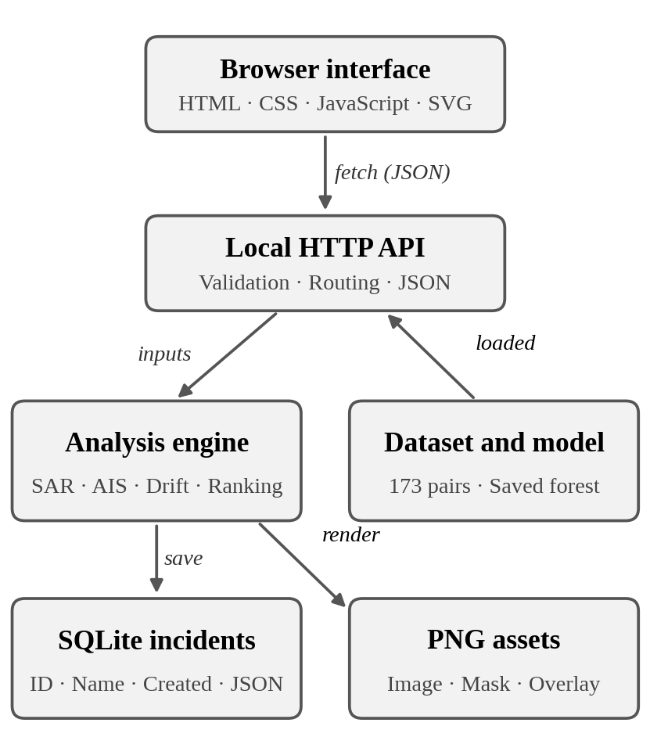
Fig. 1. Implemented components and data flow. The Python server binds to the local computer only. JSON report and GeoJSON exports are generated from saved incident snapshots.
The interface has three pages. The investigation workspace lists saved cases with search and shows the selected case with its evidence, and it can run the fictional vessel demonstration, screen a public test image, reopen or delete a case and download reports. The new-analysis page takes a name, a UTC observation time, a PNG or JPEG file, a method selector, an AIS CSV file, geographic bounds, drift inputs and notes. The methodology page lists the data source, the measured test metrics, the drift assumptions, the ranking formula and the limitations.
JavaScript reads local files, submits a JSON request and renders the response. Request buttons are disabled while an analysis runs, and status and error text is placed in an aria-live region. Form controls have labels, and navigation and actions can be reached from the keyboard in the markup, following basic accessibility guidance [29]. User-provided names and notes are inserted as text or escaped before HTML rendering. Responsive CSS rearranges the panels on small screens, but the layout still needs a manual desktop and mobile browser check.
The geographic view is an SVG longitude–latitude plot with source circles, region centroids and vessel trajectories. It is not a basemap and does not show coastlines. Each selected age is drawn from the nine computed age hypotheses, and image-only analyses deliberately leave out geographic inference.
VI. ANALYSIS METHODS
A. Image Segmentation
A random forest classifies each pixel of the 200 × 150 working image. Twelve features are computed from the grey-scale image: the intensity itself; the local mean, local standard deviation and intensity-minus-mean at three window sizes (2, 5 and 11); the Sobel gradient magnitude; and the scene-average intensity. The forest has 48 trees, a maximum depth of 14 and a minimum leaf size of 8. The decision threshold is chosen by the highest validation IoU over 0.20 to 0.80 in steps of 0.05, and the selected value is 0.80. Connected components of at least 12 pixels are kept, and up to the 20 largest regions go into the geographic analysis. Region statistics describe candidate slicks and not confirmed oil.
B. Source Estimation
The effective transport velocity combines an entered current c and a wind w scaled by a windage factor α:
v = c + α w (1)
For each region centroid and each age t, the estimated source is the observed position moved backwards along this velocity. Nine equally spaced ages cover the analyst-entered interval. A local flat-earth conversion turns metres into degrees, using 111,320 m per degree of latitude φ and 111,320 cos φ m per degree of longitude λ:
Δφ = −v_{n}t / 111320, Δλ = −v_{e}t / (111320 cos φ) (2)
where v_{n} and v_{e} are the north and east parts of v. The assumed radius of the source circle grows with age as
r(t) = 250 + σt (3)
with t in seconds and σ the entered uncertainty rate in m/s. It is an analyst-defined envelope and not a calibrated confidence region. Fig. 2 illustrates the geometry. Inputs are limited to small, north-up scenes away from the poles and the antimeridian, and the method ignores time-varying currents, spreading, coastlines and weathering.
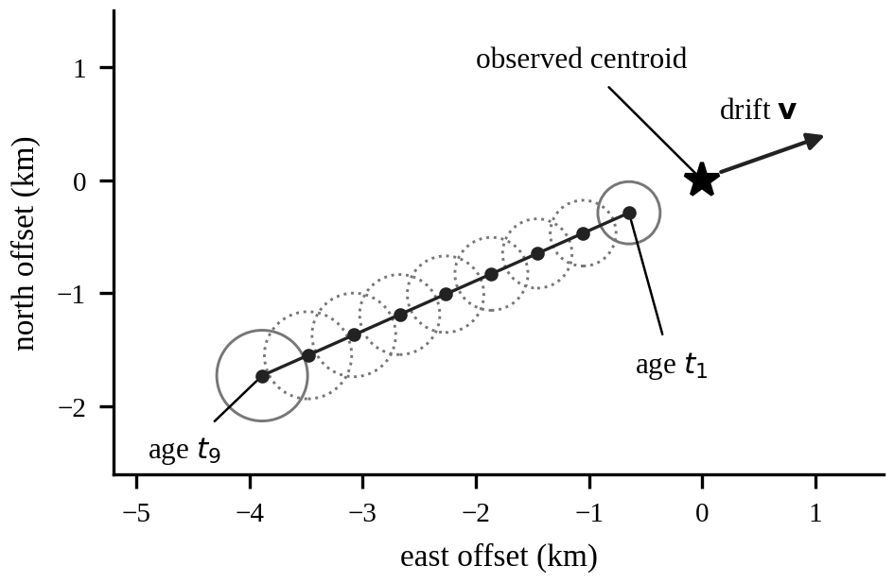
Fig. 2. Conceptual back-tracking geometry for one region centroid and nine ages. The velocity and radius growth are illustrative values chosen for the drawing. It is not a measured or fitted result.
C. Vessel Association
AIS records are grouped by MMSI and sorted by time. Identical duplicate rows are collapsed, and conflicting positions for the same vessel and time are rejected. Linear interpolation is allowed only between observations. It is blocked across gaps longer than 30 minutes and across implied speeds above 25 m/s, and positions are never extrapolated.
For a vessel at distance d from a source circle of radius r at the same time, the spatial agreement is
a = exp[−½ (d/r)²] (4)
Each vessel uses its strongest match over the source hypotheses. Temporal coverage τ is the fraction of hypotheses that have an eligible interpolated vessel position, and completeness κ is 1 for a multi-record track and 0.5 for a single-record track. The heuristic score is
S = 100 (0.70 a + 0.20 τ + 0.10 κ) (5)
Candidates with a below 0.1 are omitted, which corresponds to d/r above √(2 ln 10) ≈ 2.15 (Fig. 3). The score ranks associations. It is not the probability that a vessel caused the slick.
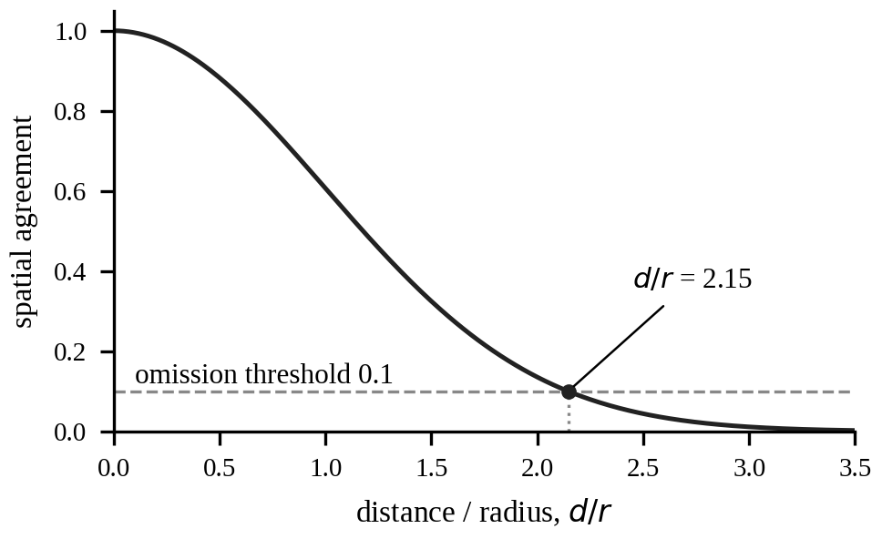
Fig. 3. Spatial agreement as a function of distance divided by radius, from Eq. (4). The dotted line marks the omission threshold of 0.1, reached at d/r = 2.15.
VII. BACKEND AND STORAGE IMPLEMENTATION
The backend exposes ten routes (Appendix D). Health and metrics routes report server, model and dataset status and the executed test metrics. A sample route loads a public test image for image-only screening, and the incident routes analyse and save a new investigation, list summaries, reopen a full snapshot, download a JSON report or GeoJSON features, and delete an incident together with its generated images. A separate demonstration route runs the labelled fictional AIS example. Requests and results are JSON [30], and source polygons and vessel tracks are exported as GeoJSON features [31].
Incidents are stored in a single SQLite table [32] (Table III). The database file is runtime/bluetrace.db, and each incident owns image.png, mask.png and overlay.png in its own folder. The JSON snapshot holds the observation time, notes, model, bounds, environmental inputs, regions, source hypotheses, candidate evidence, tracks and export features. Raw uploaded bytes are not kept at original resolution, because the displayed analysis image is resized.
TABLE III
PERSISTENT SCHEMA OF THE incidents TABLE
Field | SQLite type | Role
id | TEXT PRIMARY KEY | Generated 32-character incident identifier
name | TEXT NOT NULL | Analyst-provided investigation label
created | TEXT NOT NULL | UTC save time
result | TEXT NOT NULL | Complete JSON result and input snapshot

Invalid input returns HTTP 400, a disallowed host or origin 403, an unknown resource 404, an oversized request 413 and a competing analysis 429. The service limits request and image sizes, checks timestamps and coordinates, and serializes analysis with a lock. SQL uses bound parameters, which addresses the injection risk listed in common web security guidance [33]. A failed analysis removes its partial assets. The server is restricted to loopback and is not a production deployment.
VIII. EXPERIMENTAL METHOD
A. Dataset and Provenance
The package includes the Garcia-INPE Oil Spill Segmentation Dataset [34], which contains SAR-derived imagery from the Cantarell region and is licensed CC BY 4.0. The download is pinned to one repository commit, and the original attribution and licence are kept with the data. Table IV gives the partitions. Original images and single-channel masks are included without byte modification. Download verification checks Git LFS SHA256 values, and provenance.json records a hash for every included source file. Integrity tests confirm that images and masks are aligned, that sample identities are unique and that no source-image group appears in two splits.
TABLE IV
DATASET PARTITIONS
Partition | Image–mask pairs | Source image groups
Training | 108 | 16
Validation | 43 | 4
Held-out test | 22 | 4
Total | 173 | 24

Images are resized to 200 × 150 pixels with bilinear interpolation and masks with nearest-neighbour resampling. Inspection found mask values 0, 1 and 2. The binary target is mask > 0, so both nonzero values count as slick, which follows the repository benchmark convention and avoids assuming that the files are encoded as 0 and 1 only.
Up to 500 background and 500 slick pixels are sampled from each training tile with random seed 42, giving 85,470 training pixels. Sampling happens after the source-level split, so pixels from test acquisitions never enter training. The validation set chooses the decision threshold, and the test set is used for the final measurement only.
B. Baseline and Metrics
The comparator is a dark-percentile rule that marks the darkest pixels of each tile as slick. It is evaluated on the same 22 test tiles. All metrics use global pixel counts: IoU [35], precision, recall, F1 and pixel accuracy (Appendix C). Because slicks are rare, precision and IoU are more informative than accuracy [36].
C. Synthetic Geographic Fixture
The vessel stage is exercised with an independent synthetic dataset. It has one generated SAR-style image and its mask, 57 AIS rows for three explicitly fictional vessels at 15-minute spacing over 4.5 hours, environmental inputs and a complete JSON request. These tracks have no relationship to the public SAR images and are never described as observed vessel-source evidence.
Table V lists the experiments that are still needed to validate the workflow beyond the local baseline.
TABLE V
PLANNED VALIDATION EXPERIMENTS (PROSPECTIVE)
Experiment | Condition / comparison | Main metric
Real-case association | SAR scene with independent AIS and a known release | Rank of true source
Cross-site generalization | Leave-one-source-group-out and other regions | Per-group IoU
Model comparison | Random forest vs. a small CNN | IoU, ms per tile
Drift sensitivity | Sweep current, windage and uncertainty | Rank stability
Threshold range | Search above 0.80 | Validation IoU
Browser QA | Desktop and mobile manual check | Layout defects

IX. IMPLEMENTATION RESULTS AND OBSERVED OUTPUT
A. Scope and Setup
All numbers in this section come from the executed local package. The model was evaluated on the 22 held-out images at 200 × 150 pixels, which is 660,000 working-resolution pixels. Timings were recorded in a Linux environment, and the interface screenshots were taken at 127.0.0.1:8000 on a Windows workstation in October 2026. Training and evaluation took 9.72 s in total, and the median inference time was 44.9 ms per test tile, excluding HTTP, disk and upload costs. These are single-run timings and not a production benchmark.
B. Segmentation Results
Table VI and Fig. 4 compare the trained forest with the dark-percentile baseline. The forest raises slick IoU from 6.64% to 53.26% and F1 from 12.45% to 69.51%, at the cost of a lower recall (90.07% against 99.65%). The baseline recall is high only because it flags a large share of every tile; its precision equals its IoU at 6.64%, and from its pixel accuracy of 84.64% we infer that it marks roughly one sixth of all pixels as slick, which is a derived estimate and not a recorded count.
TABLE VI
HELD-OUT SEGMENTATION METRICS (22 TILES)
Metric | Random forest | Dark baseline
Slick IoU | 53.26% | 6.64%
Precision | 56.59% | 6.64%
Recall | 90.07% | 99.65%
F1 score | 69.51% | 12.45%
Pixel accuracy | 99.13% | 84.64%

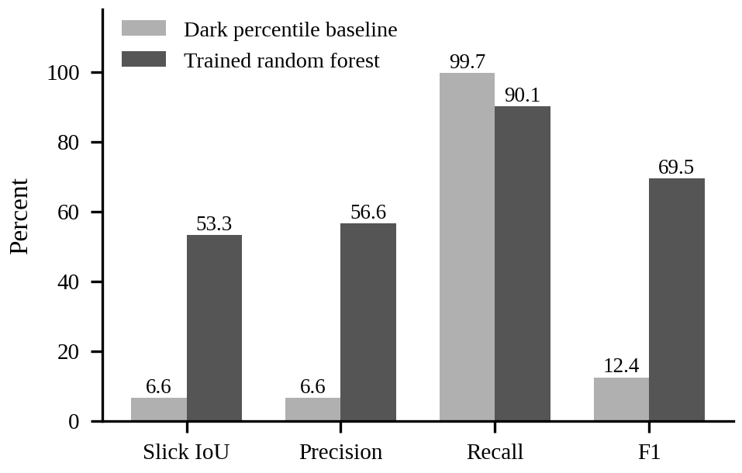
Fig. 4. Executed comparison on 22 held-out images at 200 × 150 pixels. Higher is better for all four metrics.
Across the 660,000 test pixels the forest produced the counts in Table VII. Slick prevalence is only 1.10%, so the 99.13% pixel accuracy is dominated by background. A precision of 56.59% means that many predicted slick pixels are false positives, while a recall of 90.07% means that most labelled slick pixels were recovered in this partition. These numbers support a screening baseline and not operational detection reliability. The evaluation does not measure oil chemistry or vessel attribution.
TABLE VII
CONFUSION COUNTS FOR THE RANDOM FOREST (660,000 PIXELS)
Count | Pixels | Share
True positives | 6,511 | 0.99%
False positives | 4,995 | 0.76%
False negatives | 718 | 0.11%
True negatives | 647,776 | 98.15%

The median time of 44.9 ms per tile corresponds to an upper bound of about 22 tiles per second for inference alone, and this is a derived figure and not a measured server throughput.
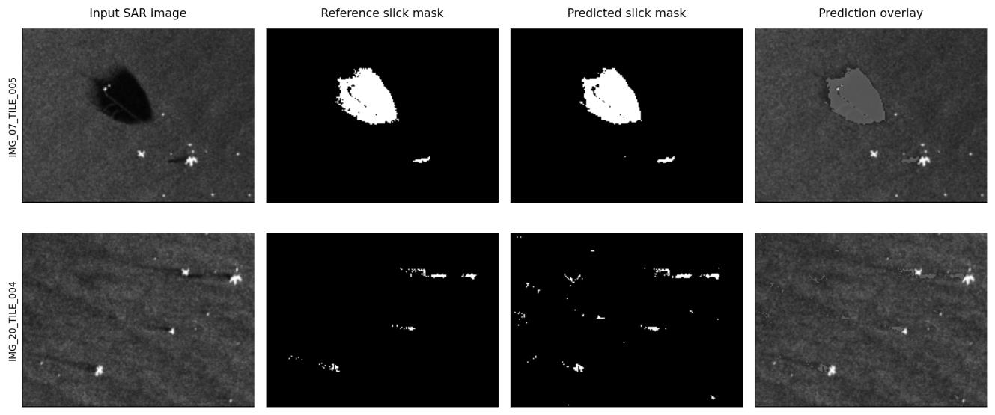
Fig. 5. Actual trained-model predictions on two held-out images. Rows show the highest-IoU example (IMG_07_TILE_005) and the median-ranked example (IMG_20_TILE_004). This selection shows variation and is not an average performance claim.
Fig. 5 makes false positives and missed regions visible. The first row shows a large slick that is segmented closely, and the second row shows scattered false-positive specks and some missed regions. All 22 image-level metrics are available in reports/test_per_image.csv, so the examples can be checked against the complete evaluation.
C. Fictional Vessel Demonstration
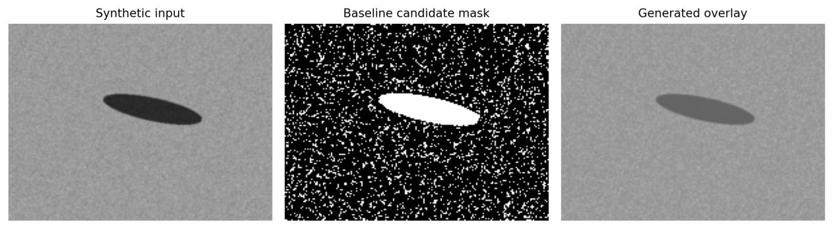
Fig. 6. Generated outputs from the synthetic geographic fixture using the dark-region baseline: input, baseline candidate mask and overlay.
The fictional end-to-end run produced 5 retained candidate regions, 45 source hypotheses (5 regions × 9 ages) and 2 supported candidate vessel associations out of the 3 fictional vessels. These counts show executed software behaviour under the supplied assumptions. They are not measured real-spill detection or attribution accuracy. Table VIII gives the leading fictional candidate.
TABLE VIII
LEADING FICTIONAL CANDIDATE (SOFTWARE OUTPUT)
Item | Observed software output
Vessel | FICTIONAL Aster / 900000001
Heuristic score | 87.7 out of 100
Distance to matched source | 1498.1 m
Matched source time | 2026-09-18T02:40:00+00:00

D. Software Verification
The current implementation passed 23 automated tests, and the JavaScript syntax check also passed. The original dataset file hashes and every image–mask pairing were checked. Table IX groups the tests by area.
TABLE IX
AUTOMATED TEST AREAS (23 TESTS PASSED)
Test area | Checks | Result
Image and input validation | Bad image, invalid bounds, NaN and timezone rejection | Passed
AIS processing | Conflict rejection, sort and de-duplicate, gap and speed guards, interpolation arithmetic, no extrapolation | Passed
Metrics and dataset | Metric arithmetic, pair and split integrity, all file checksums | Passed
Full HTTP lifecycle | Analyse, save, list, reopen, assets, JSON and GeoJSON export, deletion | Passed
Security and failures | Host and origin rejection, static CSP, invalid-input clean-up, busy response, path traversal | Passed
Real model API | Public image-only inference and the metrics endpoint | Passed

Table X separates what these runs support from the claims that still need validation. Passing tests and a working interface do not satisfy the real-attribution or browser-usability gates.
TABLE X
EVIDENCE STATUS OF THE CURRENT BUILD
Item | Result / evidence
Dataset integrity | 173 pairs, hash-verified; 352 downloaded files including manifests and attribution
Held-out segmentation | IoU 53.26%, precision 56.59%, recall 90.07% (22 tiles)
Inference and training time | 44.9 ms median per tile; 9.72 s total; single run
Vessel association | Fictional demonstration only; no real source-vessel validation
Browser interaction QA | Not yet performed
Production hosting, login, live AIS | Outside the local scope

E. Reproduction and Evidence
To repeat the work, create the virtual environment from the pinned requirements, start the server with the supplied start script and open 127.0.0.1:8000. The unit tests are run with unittest. The package contains the saved model, the dataset manifests and provenance file, reports/test_per_image.csv, the test results text and the exported metrics and demonstration JSON files. Figs. 7 and 8 are unedited browser screenshots of image-only investigations. Fig. 7 shows Analysis 03 (IMG_20_TILE_001) with 2 candidate regions, 1.0% predicted slick pixels and 0 vessel candidates, and Fig. 8 shows Analysis 04 (IMG_26_TILE_001) with 1 candidate region, 0.3% predicted slick pixels and 0 vessel candidates. Image-only cases have no vessel candidates by design.
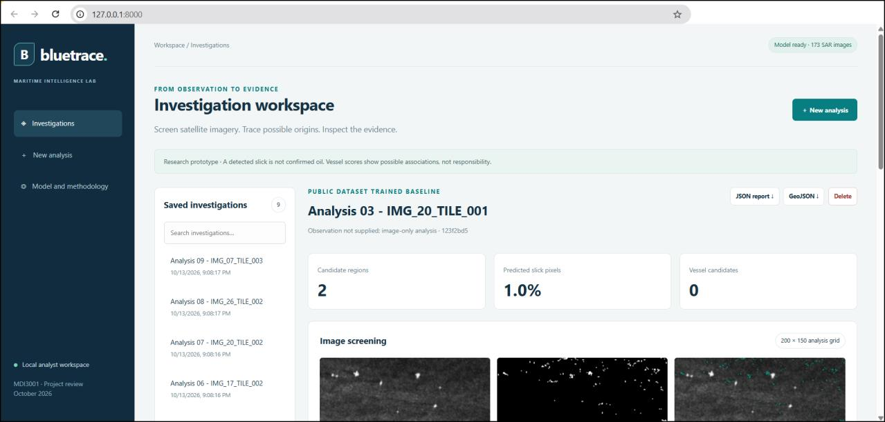
Fig. 7. Browser view at 127.0.0.1:8000 of Analysis 03 (IMG_20_TILE_001). The banner states that a detected slick is not confirmed oil and that vessel scores show possible associations, not responsibility.
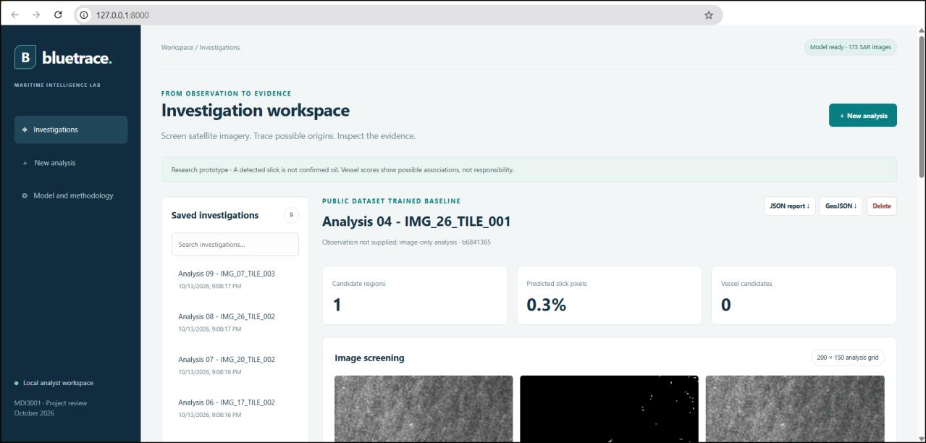
Fig. 8. Browser view of Analysis 04 (IMG_26_TILE_001): 1 candidate region, 0.3% predicted slick pixels and 0 vessel candidates.
X. LIMITATIONS AND THREATS TO VALIDITY
A detected slick is a candidate and not confirmed oil, since look-alikes remain possible [3]. The test set has only four source-image groups from one region, so broader geographic generalization is not established. Precision is modest, with 4,995 false-positive pixels against 6,511 true positives. The selected threshold of 0.80 lies at the upper edge of the searched range, so a wider search might choose a higher value. Merging mask values 1 and 2 into one class, and resizing to 200 × 150 pixels, can hide small or fine structures.
The drift model uses one constant velocity. It ignores time-varying currents, spreading, coastlines and weathering, and the radius is an analyst-defined envelope and not a calibrated confidence region. Only vessels that transmit AIS can appear, and the score ranks associations without giving a probability. The vessel stage has been run only on a fictional fixture, so no attribution accuracy can be stated. The system has one analyst role, no login, no live data and no legal standing. Timings are single runs, and the responsive layout and keyboard use have not been checked in a manual browser session.
XI. CONCLUSION
We presented Bluetrace, a local web workflow that joins SAR slick screening, back-tracked source estimation and guarded AIS association, with persistent investigations and standard exports. On 22 held-out tiles from four source-image groups the random forest reached a slick IoU of 53.26%, compared with 6.64% for the dark-percentile baseline, while still producing material false positives (precision 56.59%). The fictional demonstration and the 23 passing tests show that the workflow runs end to end under stated assumptions. They do not show real attribution accuracy, so validation on real co-registered SAR and AIS cases and a manual browser check are still needed.
APPENDIX A: EXPERIMENT REGISTER
A1 (Real-case association): Run the workflow on a SAR scene with independent AIS data and a documented release, and report the rank of the true source.
A2 (Cross-site generalization): Evaluate leave-one-source-group-out IoU and test on imagery from regions other than Cantarell.
A3 (Model comparison): Compare the random forest with a small convolutional network on the same split, reporting IoU and milliseconds per tile.
A4 (Threshold range): Extend the validation search beyond 0.80 and report the precision–recall trade-off.
A5 (Feature ablation): Remove each feature group (local statistics, gradient, scene mean) and measure the change in IoU.
A6 (Drift sensitivity): Sweep current, windage and uncertainty and report how candidate ranks change.
A7 (Radius calibration): Compare the assumed radius with known release positions to see whether it covers them.
A8 (AIS guard sensitivity): Vary the 30-minute gap and 25 m/s speed limits and record how many candidates change.
A9 (Time-varying forcing): Replace constant velocity with gridded current and wind data and compare source areas.
A10 (Per-image analysis): Study the 22 per-image metrics to find which scenes cause false positives.
A11 (Browser and accessibility QA): Check desktop and mobile layouts, keyboard use and screen-reader labels by hand.
A12 (Repeatability): Repeat training and evaluation with several seeds and report the spread of IoU and timings.
APPENDIX B: MINIMUM RELEASE CHECKLIST
A complete release needs: (1) the full source code with a recorded hash; (2) pinned dependency versions; (3) the dataset manifests, checksums and provenance file; (4) the saved model with its training seed and threshold; (5) the per-image test metrics and confusion counts; (6) the fictional demonstration files, clearly labelled; (7) the automated test suite with its output; and (8) screenshots of the interface from a manual browser check.
APPENDIX C: ANALYSIS DEFINITIONS AND DATA DICTIONARY
With TP, FP, FN and TN counted over all test pixels: IoU = TP/(TP+FP+FN), precision = TP/(TP+FP), recall = TP/(TP+FN), F1 = 2TP/(2TP+FP+FN) and accuracy = (TP+TN)/(TP+FP+FN+TN). For the forest, 6,511/12,224 = 53.26% IoU, and the four counts sum to 660,000. Table XI lists the data exchanged by the application.
TABLE XI
DATA DICTIONARY
Data | Important fields
AIS CSV | mmsi, timestamp, latitude, longitude; optional name
Split CSV | sample_id, image_path, mask_path; preserved publisher manifests
Environmental JSON | Current and wind east and north in m/s, windage, uncertainty, minimum and maximum age
Provenance JSON | Pinned repository commit, source paths, byte sizes and SHA256 hashes

APPENDIX D: API ROUTES
Table XII lists the routes of the local HTTP service.
TABLE XII
BACKEND ROUTES
Method and route | Purpose
GET /api/health | Read server, model and dataset status
GET /api/metrics | Read executed validation and test metrics
GET /api/dataset/sample | Load a public test image for image-only screening
GET /api/incidents | List saved summaries
POST /api/incidents | Validate inputs, analyse and save a new investigation
POST /api/demo | Run the labelled fictional AIS demonstration
GET /api/incidents/{id} | Reopen a full incident snapshot
GET /api/incidents/{id}/report | Download JSON inputs, results and evidence
GET /api/incidents/{id}/geojson | Download source polygons and vessel tracks
POST /api/incidents/{id}/delete | Remove the incident and its generated images

REFERENCES
[1] C. Brekke and A. H. S. Solberg, “Oil spill detection by satellite remote sensing,” Remote Sens. Environ., vol. 95, no. 1, pp. 1–13, 2005.
[2] M. Fingas and C. Brown, “Review of oil spill remote sensing,” Mar. Pollut. Bull., vol. 83, no. 1, pp. 9–23, 2014.
[3] W. Alpers, B. Holt, and K. Zeng, “Oil spill detection by imaging radars: Challenges and pitfalls,” Remote Sens. Environ., vol. 201, pp. 133–147, 2017.
[4] International Telecommunication Union, “Technical characteristics for an automatic identification system using time-division multiple access in the VHF maritime mobile band,” Recommendation ITU-R M.1371-5, 2014.
[5] A. H. S. Solberg, G. Storvik, R. Solberg, and E. Volden, “Automatic detection of oil spills in ERS SAR images,” IEEE Trans. Geosci. Remote Sens., vol. 37, no. 4, pp. 1916–1924, 1999.
[6] K. N. Topouzelis, “Oil spill detection by SAR images: Dark formation detection, feature extraction and classification algorithms,” Sensors, vol. 8, no. 10, pp. 6642–6659, 2008.
[7] F. Del Frate, A. Petrocchi, J. Lichtenegger, and G. Calabresi, “Neural networks for oil spill detection using ERS-SAR data,” IEEE Trans. Geosci. Remote Sens., vol. 38, no. 5, pp. 2282–2287, 2000.
[8] K. Topouzelis and A. Psyllos, “Oil spill feature selection and classification using decision tree forest on SAR image data,” ISPRS J. Photogramm. Remote Sens., vol. 68, pp. 135–143, 2012.
[9] M. Kubat, R. C. Holte, and S. Matwin, “Machine learning for the detection of oil spills in satellite radar images,” Mach. Learn., vol. 30, no. 2–3, pp. 195–215, 1998.
[10] S. Skrunes, C. Brekke, and T. Eltoft, “Characterization of marine surface slicks by Radarsat-2 multipolarization features,” IEEE Trans. Geosci. Remote Sens., vol. 52, no. 9, pp. 5302–5319, 2014.
[11] A. H. S. Solberg, “Remote sensing of ocean oil-spill pollution,” Proc. IEEE, vol. 100, no. 10, pp. 2931–2945, 2012.
[12] B. Fiscella, A. Giancaspro, F. Nirchio, P. Pavese, and P. Trivero, “Oil spill detection using marine SAR images,” Int. J. Remote Sens., vol. 21, no. 18, pp. 3561–3566, 2000.
[13] J. Long, E. Shelhamer, and T. Darrell, “Fully convolutional networks for semantic segmentation,” in Proc. IEEE CVPR, 2015, pp. 3431–3440.
[14] O. Ronneberger, P. Fischer, and T. Brox, “U-Net: Convolutional networks for biomedical image segmentation,” in Proc. MICCAI, LNCS 9351, 2015, pp. 234–241.
[15] M. Krestenitis, G. Orfanidis, K. Ioannidis, K. Avgerinakis, S. Vrochidis, and I. Kompatsiaris, “Oil spill identification from satellite images using deep neural networks,” Remote Sens., vol. 11, no. 15, art. 1762, 2019.
[16] X. X. Zhu et al., “Deep learning in remote sensing: A comprehensive review and list of resources,” IEEE Geosci. Remote Sens. Mag., vol. 5, no. 4, pp. 8–36, 2017.
[17] L. Breiman, “Random forests,” Mach. Learn., vol. 45, no. 1, pp. 5–32, 2001.
[18] F. Pedregosa et al., “Scikit-learn: Machine learning in Python,” J. Mach. Learn. Res., vol. 12, pp. 2825–2830, 2011.
[19] Ø. Breivik, A. A. Allen, C. Maisondieu, and J. C. Roth, “Wind-induced drift of objects at sea: The leeway field method,” Appl. Ocean Res., vol. 33, no. 2, pp. 100–109, 2011.
[20] Ø. Breivik and A. A. Allen, “An operational search and rescue model for the Norwegian Sea and the North Sea,” J. Mar. Syst., vol. 69, no. 1–2, pp. 99–113, 2008.
[21] K.-F. Dagestad, J. Röhrs, Ø. Breivik, and B. Ådlandsvik, “OpenDrift v1.0: A generic framework for trajectory modelling,” Geosci. Model Dev., vol. 11, no. 4, pp. 1405–1420, 2018.
[22] W. Lehr, R. Jones, M. Evans, D. Simecek-Beatty, and R. Overstreet, “Revisions of the ADIOS oil spill model,” Environ. Model. Softw., vol. 17, no. 2, pp. 189–197, 2002.
[23] M. L. Spaulding, “State of the art review and future directions in oil spill modeling,” Mar. Pollut. Bull., vol. 115, no. 1–2, pp. 7–19, 2017.
[24] Y. Liu, R. H. Weisberg, C. Hu, and L. Zheng, “Tracking the Deepwater Horizon oil spill: A modeling perspective,” Eos Trans. AGU, vol. 92, no. 6, pp. 45–46, 2011.
[25] R. Pelich, N. Longépé, G. Mercier, G. Hajduch, and R. Garello, “AIS-based evaluation of target detectors and SAR sensors characteristics for maritime surveillance,” IEEE Trans. Geosci. Remote Sens., vol. 53, no. 8, pp. 3892–3901, 2015.
[26] D. A. Kroodsma et al., “Tracking the global footprint of fisheries,” Science, vol. 359, no. 6378, pp. 904–908, 2018.
[27] C. R. Harris et al., “Array programming with NumPy,” Nature, vol. 585, pp. 357–362, 2020.
[28] P. Virtanen et al., “SciPy 1.0: Fundamental algorithms for scientific computing in Python,” Nat. Methods, vol. 17, pp. 261–272, 2020.
[29] World Wide Web Consortium, “Web Content Accessibility Guidelines (WCAG) 2.1,” W3C Recommendation, Jun. 2018.
[30] T. Bray, Ed., “The JavaScript Object Notation (JSON) Data Interchange Format,” RFC 8259, IETF, Dec. 2017.
[31] H. Butler, M. Daly, A. Doyle, S. Gillies, S. Hagen, and T. Schaub, “The GeoJSON Format,” RFC 7946, IETF, Aug. 2016.
[32] SQLite Consortium, “SQLite documentation.” [Online]. Available: https://www.sqlite.org/docs.html
[33] OWASP Foundation, “OWASP Top 10:2021,” 2021.
[34] J. R. M. Garcia, “Garcia-INPE Oil Spill Segmentation Dataset,” public dataset repository, CC BY 4.0, pinned commit 1b9a62c30a9da9698eb470562aa976f9bd1e8fc3.
[35] M. Everingham, L. Van Gool, C. K. I. Williams, J. Winn, and A. Zisserman, “The PASCAL Visual Object Classes (VOC) challenge,” Int. J. Comput. Vis., vol. 88, no. 2, pp. 303–338, 2010.
[36] T. Saito and M. Rehmsmeier, “The precision-recall plot is more informative than the ROC plot when evaluating binary classifiers on imbalanced datasets,” PLOS ONE, vol. 10, no. 3, art. e0118432, 2015.

